### **🔄 What is "GitHub hook trigger for GITScm polling"?**

This is a **trigger mechanism** used in Jenkins jobs where **GitHub Webhooks** notify Jenkins when there’s a new commit/push. However, unlike "Poll SCM", Jenkins **does not poll on a schedule**. Instead:

1. **GitHub sends a webhook** to Jenkins when code is pushed.
2. The **GitHub Plugin in Jenkins** verifies:  
   * Is this webhook from a GitHub repo?
   * Does this match the repo URL in the Jenkins job's SCM config?
3. If yes, the plugin **triggers a one-time SCM polling**.
4. **Git Plugin (not GitHub Plugin)** performs the actual polling.  
   * If it detects a change → Jenkins job is triggered and a build is started.

### **🧠 Example Use Case**

* You push code to GitHub.
* GitHub sends a webhook to Jenkins (configured in repo settings).
* Jenkins receives it (via GitHub Plugin).
* Jenkins polls the repo once.
* If new changes are detected, a build is triggered.

### **✅ Why Use This Instead of Poll SCM?**

* **More efficient** — no constant scheduled checks.
* **Instant feedback** — builds run right after a push.
* **Less load** on GitHub and Jenkins.

### **🧩 Additional Setup Required**

To use this:

1. **In Jenkins job** → Check: GitHub hook trigger for GITScm polling
2. **In GitHub repo** → Settings → Webhooks:  
   * Payload URL: http://<jenkins-url>/github-webhook/
   * Content type: application/json
   * Events: Push events (default is fine)

### **✅ GitHub Hooks – Jenkins Integration**

📌 **Purpose**:  
 When a **commit is pushed to a GitHub repository**, Jenkins gets notified and **triggers a job** automatically (without polling).

### **🛠️ Step-by-Step Setup**

1. **Login to GitHub**
   * Go to: https://github.com
   * Sign in with **username** and **password**
   * Navigate to your **repository** (e.g., mahalogin)
2. **Add Webhook in GitHub**
   * Go to: Settings → Webhooks
   * Click on **Add webhook**
3. **Webhook Configuration**
   * **Payload URL**: http://<Public-IP>:8080/github-webhook/

(Replace <Public-IP> with your Jenkins server’s IP)

* + **Content Type**: application/json
  + **Events to trigger**: ✔ Select: **Just the push event**

### **🌐 Jenkins Configuration (Job Level)**

1. **Go to your Jenkins job → Configure**
2. **Under Build Triggers, select:  
    ✅ GitHub hook trigger for GITScm polling**

**Great job setting up your Jenkins GitHub webhook integration! From the screenshots, here's a detailed verification summary and confirmation that GitHub hook trigger for GITScm polling is working perfectly in your Assignment05 job:**

**✅ Summary of Configuration**

| Component | Status |
| --- | --- |
| Job Type | Freestyle project (Correct for simple build+SCM setup) |
| SCM Config | Git URL: https://github.com/AbdulRehaman082493/mahalogin.git |
| Branch to Build | */master (Standard pattern, correct) |
| Build Trigger | ✅ GitHub hook trigger for GITScm polling selected |
| Build Step | Maven goal: clean install |
| Post-build Action | Archive Artifacts: target/*.war |
| GitHub Repo Change | README.md updated with commit (my 2nd commit) |
| Jenkins Response | ✔️ Job triggered automatically by GitHub push |
| Artifacts Built | mahaLogin-2.0.war created and archived |

### **🔗 How We Know It's Working**

* In the **build history (#1)**, it clearly shows:  
    
    
   🟢 "Started by GitHub push by AbdulRehaman082493"
* That means **GitHub webhook → Jenkins → GITScm polling → job trigger** is 100% working.

🔍 What You Could Add or Improve

| **Improvement** | **Benefit** |
| --- | --- |
| ✅ Add GitHub credentials in Jenkins | Helps in private repo access and avoids API rate limit issues |
| 🛠️ Add Email/Post Build Notifier | Notifies if a build fails or succeeds |
| 🧪 Add test reports (surefire, junit) | See test results in Jenkins UI |

## **✅ Objective**

Trigger Jenkins job automatically when code is pushed to GitHub using **GitHub Webhooks** + **GITScm polling**.

## **🧩 Step-by-Step Jenkins Configuration**

### **🔹 Step 1: Create a New Job in Jenkins**

1. Navigate to Jenkins Dashboard.
2. Click **“New Item”**.
3. Enter an item name: Assignment05.
4. Select **“Freestyle project”**.
5. Click **OK**.

📸 Screenshot shows you correctly named it and selected the right job type.

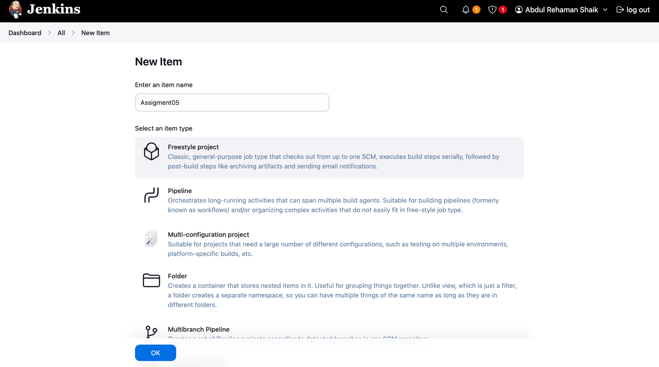

### **🔹 Step 2: Configure GitHub Repository (Source Code Management)**

1. Go to the Configure section of the job.
2. Under **Source Code Management**, choose Git.
3. Enter your repository URL: <https://github.com/AbdulRehaman082493/mahalogin.git>
4. Leave credentials as - none - (since it's a public repo).
5. Set **Branch Specifier** as: */master

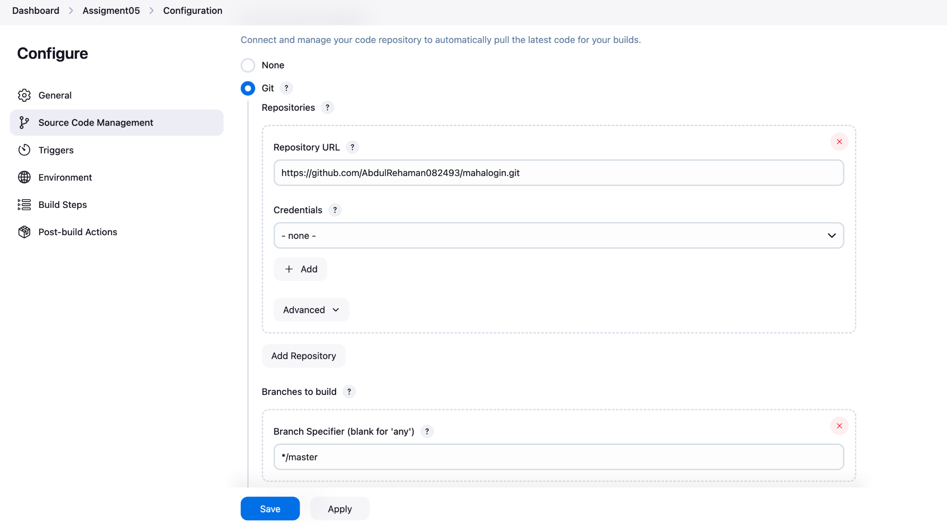

### **🔹 Step 3: Configure GitHub Trigger**

1. Go to the **Build Triggers** section.
2. Check the box:  
    ✅ GitHub hook trigger for GITScm polling

⏱️ This means Jenkins **waits for a GitHub push notification** (webhook), then **polls the repo once** to verify changes.

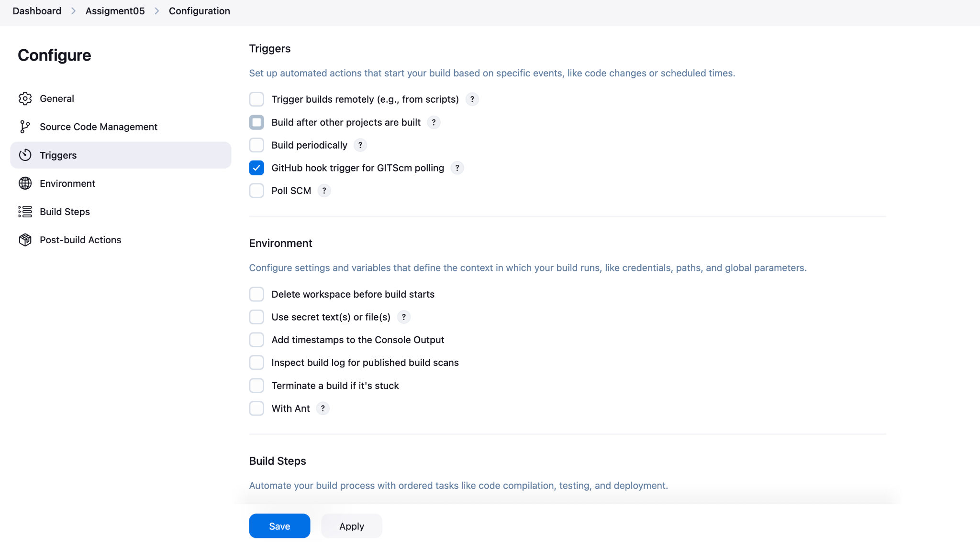

### **🔹 Step 4: Add Build Steps**

1. Go to **Build Steps**.
2. Click Add build step → select **Invoke top-level Maven targets**.
3. In the **Goals** field, enter: clean install

📦 This compiles and packages your Java/Maven project.

### 

### **🔹 Step 5: Archive WAR File**

1. Go to **Post-build Actions**.
2. Click Add post-build action → select **Archive the artifacts**.
3. Set Files to archive: target/*.war

🗂️ This stores your build artifact (e.g., mahaLogin-2.0.war) for download or deployment.

🔁 Step-by-Step GitHub Webhook Configuration

### **🔹 Step 6: Create Webhook in GitHub**

1. Go to your GitHub repo:  
    https://github.com/AbdulRehaman082493/mahalogin
2. Click on Settings → Webhooks.
3. Click **“Add webhook”**.

### **🔹 Step 7: Enter Webhook Details**

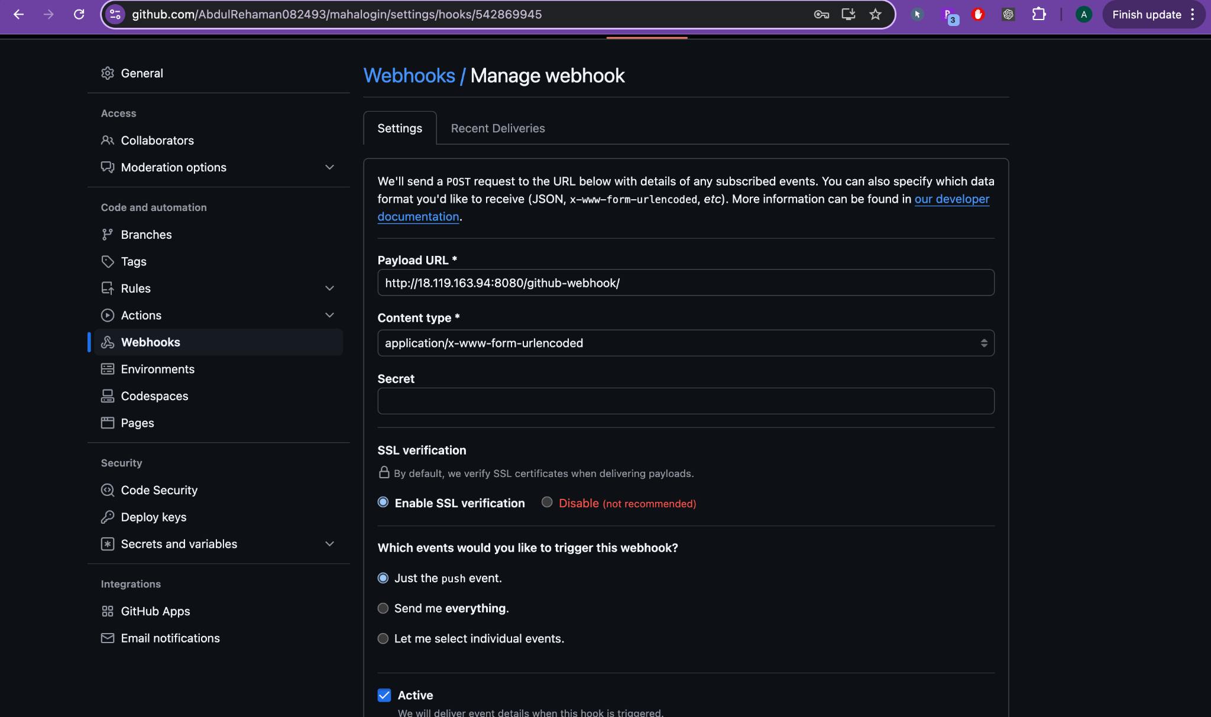

* **Payload URL**: http://<your-public-IP>:8080/github-webhook/

Replace <your-public-IP> with Jenkins server IP.

* **Content Type**: application/json
* **Trigger Event**: ✅ Select **Just the push event**

1. Click **“Add webhook”**.

📎 This notifies Jenkins every time you push code to GitHub

## **🚀 Step 8: Push to GitHub and Trigger Jenkins**

1. Edit and commit code in your repo (you edited README.md).
2. Push the changes to GitHub:

* git add README.md
* git commit -m "my 2nd commit"
* git push

## **✅ Step 9: Jenkins Automatically Builds**

* Jenkins receives webhook from GitHub.
* Triggers **GITScm polling**.
* It detects change and builds your project.
* Builds the .war file and archives it.

📸 Screenshot shows:

✔️ *Started by GitHub push by AbdulRehaman082493*

🎉 Job Assignment05 built successfully and archived mahaLogin-2.0.war.

## **📊 Summary Table**

| **Step** | **Action** | **Outcome** |
| --- | --- | --- |
| 1 | Create Freestyle Project | Jenkins job created |
| 2 | Configure Git repo | Linked to GitHub repo |
| 3 | Enable GitHub trigger | Jenkins listens for webhook |
| 4 | Add Maven build step | Project compiles with clean install |
| 5 | Archive artifact | WAR file saved |
| 6 | Add GitHub Webhook | GitHub sends push events to Jenkins |
| 7 | Commit code to GitHub | Triggers webhook |
| 8 | Jenkins builds project | ✅ Build triggered automatically |